**Profile Geometric Wallpaper in Black: Modern Elegance with a Bold Edge**

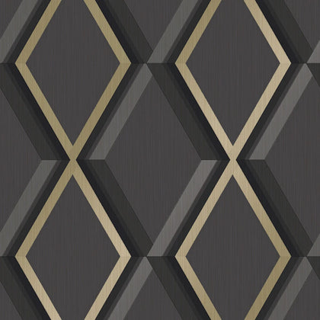Profile Geometric Wallpaper in Black offers a striking design that combines sleek geometry with bold sophistication. The deep black background creates a dramatic and modern foundation, while the clean, structured lines of the geometric patterns add a sense of depth and visual intrigue. Perfect for feature walls or creating an intimate atmosphere in living rooms, bedrooms, or study areas, this wallpaper complements contemporary, industrial, and minimalist decor styles. Its versatile yet commanding aesthetic makes it an excellent choice for those looking to add a refined and stylish statement to their space.